LAB REPORT
Step 1: Launch EC2 Instance
- Open AWS Console
- Go to EC2 → Launch Instance
- Configure:
  - Name: lab-2
  - AMI: Amazon Linux
  - Instance type: t3.micro
- Select:
  - Proceed without key pair
- Click Launch Instance
👉 Instance created successfully
👉 Instance ID: i-02d05bd15666dc170

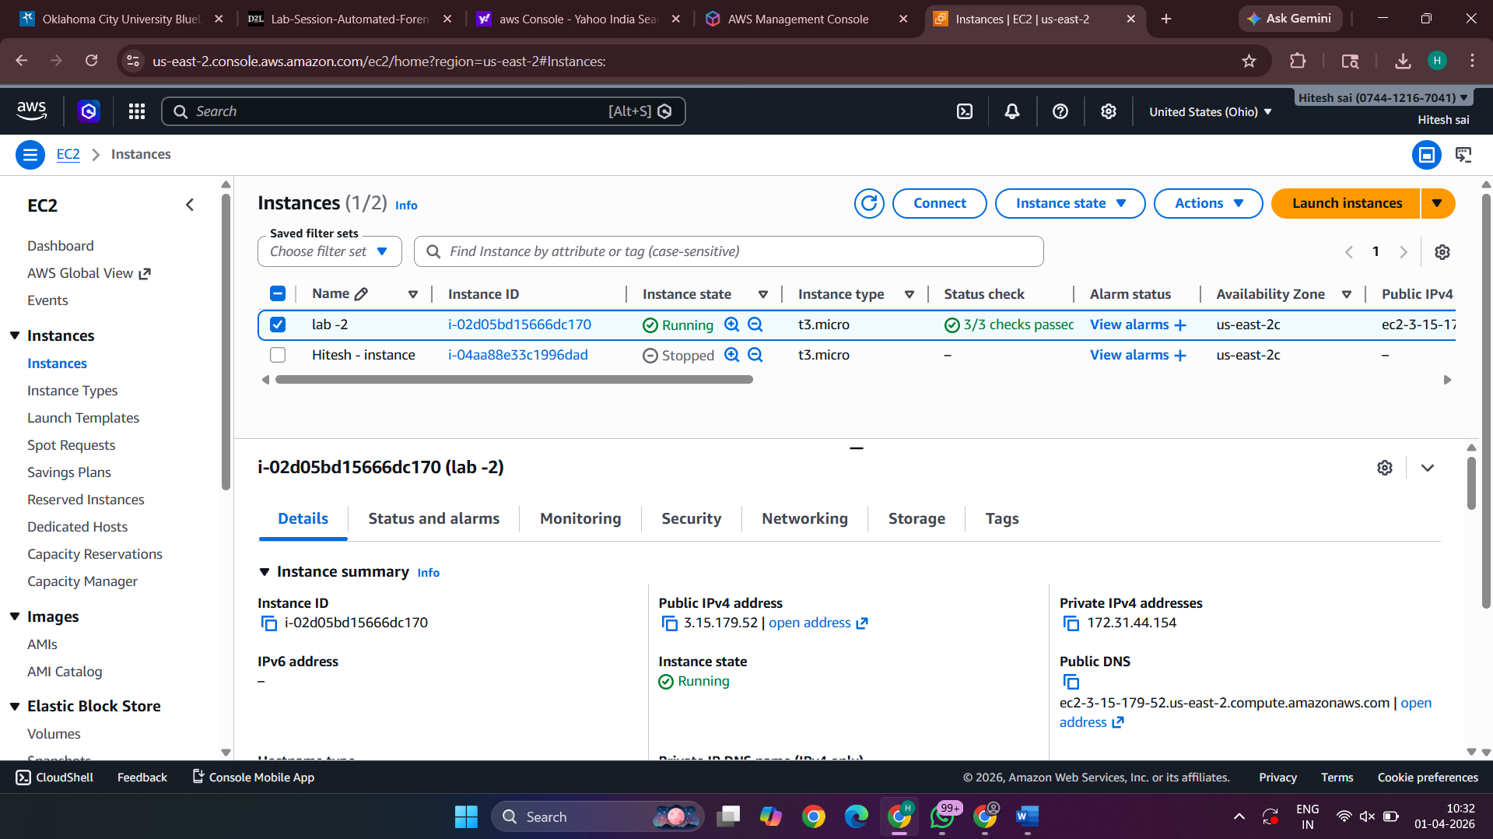

Step 2: Create Isolation Security Group
- Go to EC2 → Security Groups
- Click Create Security Group

Enter:
- Name: Forensic-Isolation-SG
- Description: Isolation group (no traffic)
- VPC: Default

Configure Rules:
Delete all inbound rules
Delete all outbound rules
Click Create Security Group

Result:
- Security Group ID:
sg-072d7777170235799
- No network access allowed

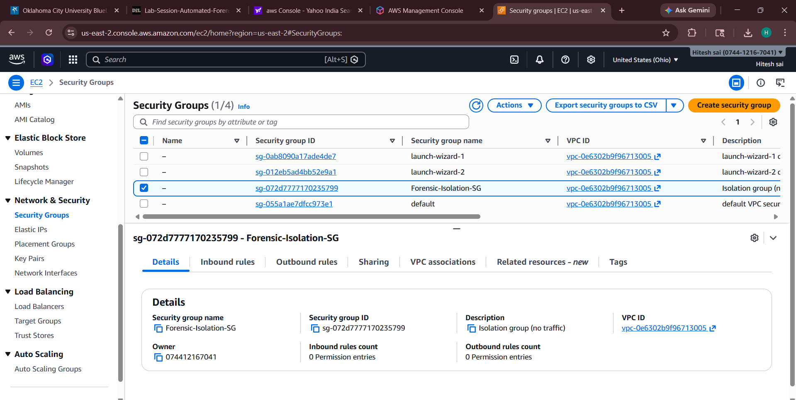

Add Permission:
- Search: AmazonEC2FullAccess
- Select checkbox

Final:
- Role name: ForensicResponderRole
- Click Create Role

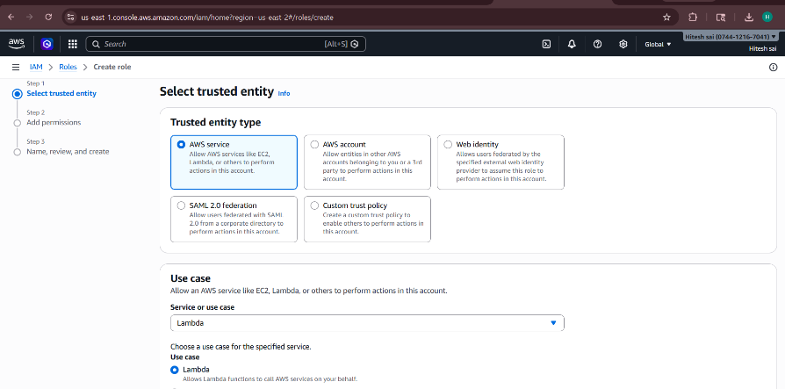

🔹 Step 5: Add Lambda Code
- Go to Code tab
- Replace default code with:

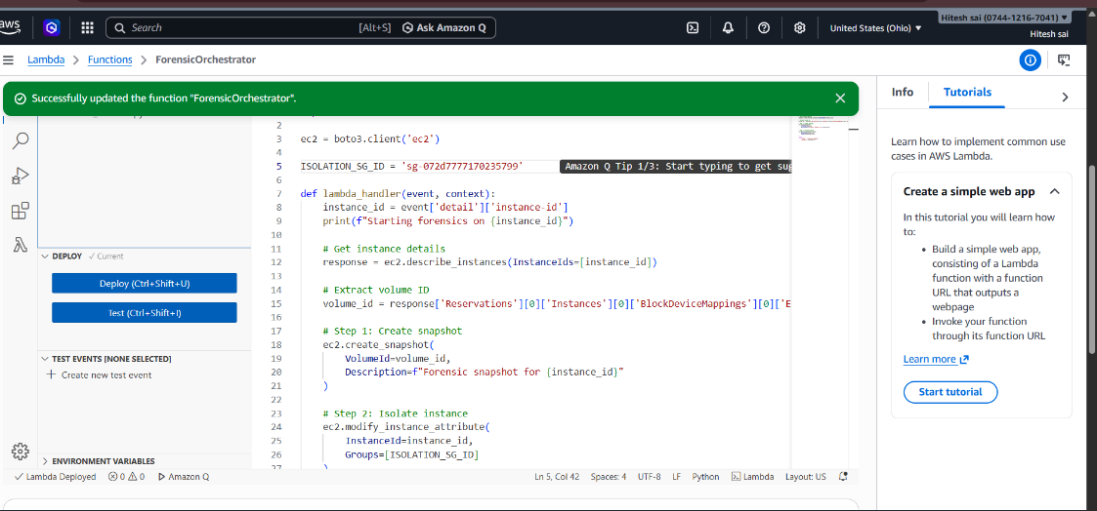
Click Deploy

Step 6: Configure Lambda Settings
- Go to Configuration → General configuration
- Click Edit

Change:
- Timeout → 2 minutes
Click Save
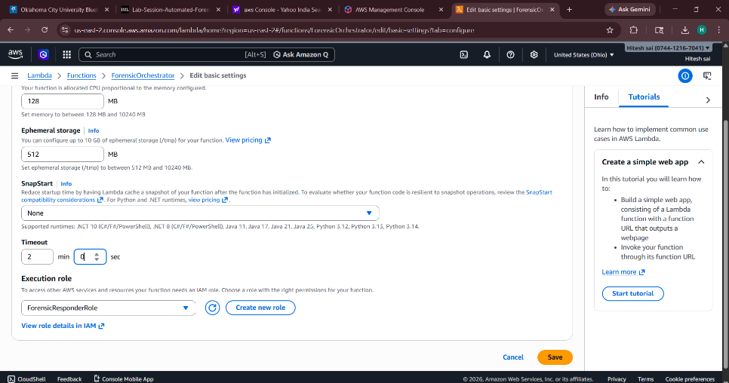

Step 7: Create Test Event
- Go to Test tab
- Click Create new event

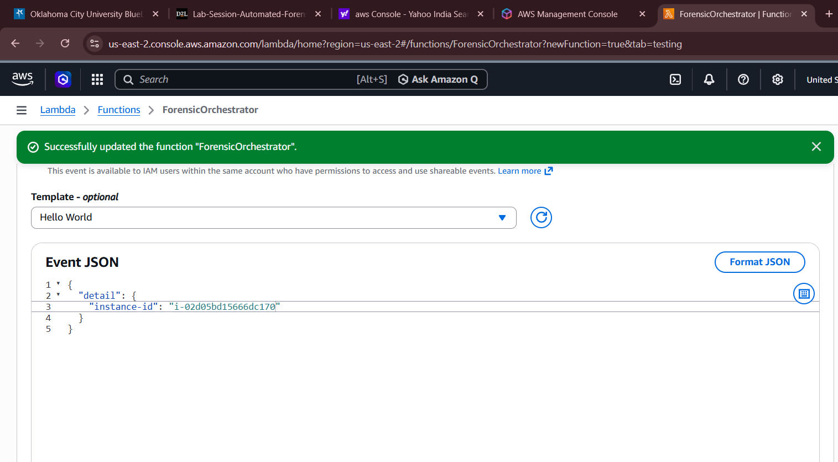

Step 8: Run the Test
Click Test

Step 9: Verification
- Go to EC2 → Instances
- Select your instance
- Open Security tab
You will see:
- Security Group:
Forensic-Isolation-SG
- No inbound/outbound rules
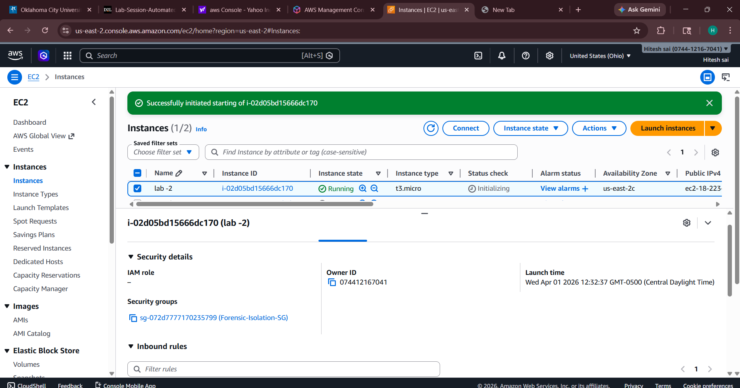

Check 2: Snapshot Created
- Go to EC2 → Snapshots
You will see:
- Snapshot created for instance
- Status: Completed
- 